Community Character Work Group
Narrative and Success Factors Working Document

Red – 9.12.19 CC meeting notes
Blue – 9.17.19 CC Meeting notes
Cindy/Kara/Mavis – edits = clean-up
(T=Technical, E=Experience, F=Focus)

As a result of our work to understand how the airport should respond to the issues of community character, the ASE Community Character Committee (CCC) recognizes, without question, the immediate need for community direction concerning the larger issues of growth and demand management. We strongly encourage the Vision Committee recommendation to the Board of County Commissioners include a coordinated process with immediate and actionable results to be undertaken by upper valley elected officials. The context of a broader, coordinated process, would address the CCC’s comments in a way that would influence the root causes of infrastructure concerns such as the airport and transportation in general. Other resort communities are approaching overuse and acknowledge the risk of losing what makes them unique as well.

The CCC recognizes our community is at risk of what makes us unique and provides the following narrative and success factors for the ASE vision process and all upper valley elected officials.

NARRATIVE
Our community has created citizen generated, character based plans since 1993. These plans represent abundant evidence of what citizen creativity, concern for our future, genuine soul searching, honest communication and collaboration can produce.

Especially when any citizen generated plan is based on the gentle mountainous and enhancement of the unique character of a place, it takes the work, thinking and cooperation of people who have connected with a place, who love a place, who love it enough to honestly grapple with the challenges--it calls for a sort of circling of the wagons around that place--or the forming of a circle like that of maternal elephants around their tiny young---it calls for a deep inside look at ourselves in order to fiercely protect what we know is vitally important.

This time around, our widely circulated and publicized slogan states, “This is why we have to get this right.“ That slogan states to our community that we are doing our best to live up to this responsibility. It would be shameful to do less.

So , the charge to the Community Character committee is quite ephemeral but vitally important as we move toward adapting our present and future needs of the airport as gently and adaptively as possible.

Some quotes from the 1993 and 2000 character based Aspen Area Master Plans stand out for the CC ….

“ ...to build character and a sense of community is far more difficult than to erode it.”

We are all aware that this place we call home is different, is quirky--its underlying character grabbed each of us and refused to let go. It is the details of what makes a place unique that we are now trying to recognize, honor and build upon. How does it appeal to our senses…touch, sound, sight?

The 2000 AAMP states “recommendations on Economic Sustainability that endeavor to make our community better without getting bigger.” We rely on economic harvests of character, clean air, quiet (as compared to the rest of the world), open lands, and preserved history.

To say it more bluntly, we make money on our unusual and unique character--people pay to come here to enjoy it and bask in it. Maintaining character makes money as well as improving our quality of life. It is also conducive to both our physical and mental health. It literally pays us to protect the goose that provides these golden eggs.

From the website of placesconsulting.org comes this description of places and their character:

“In Roman Mythology, natural places were thought to be inhabited by a residing spirit, the genius loci. We defer to the spirit of a place the emotional connection people have made to the place, based on the distinctive qualities of landscape, cultures and built environment. It is people who infuse the place with a unique spirit.

When people feel richly connected to the places where they live, work and play, they will invest more of themselves in those places. They will participate in civic life, engage in the issues that shape the future. The connection of people to a place- again to the land itself, to the cultures people have created there and of the buildings people have built there--is a form of social capital, perhaps the single most important factor in whether a real community exists in a place.

ASE Vision Consensus Principles / Continua votes
  - Target for Overall Airport Emissions: Reduce overall airport emissions (aircraft & facilities) by 20-30%. Additional request: add particulate and VOCs to “airport emissions”
  - Target for Airport Noise Intensity: Reduce noise levels by 20-30%
  - Airport Commercial Enplanement: Accommodate limited growth (target of 0.8%)

ASE COMMUNITY CHARACTER SUCCESS FACTORS
Community Character Anchors
- Consider the possibility of unintended consequences and impacts from recommendations.

Safety in the Air and on the Ground:
- Prioritize investments in policies, procedures and technology that minimize the risk of crashes, accidents, and hazardous materials spills. T
- Enhance the requirements for pilots flying into ASE Airport. T
- Develop a potential airspace zone T
- Maintain equal safety and security perimeter for commercial and GA operations (i.e. private vehicles on the tarmac.T
- Require that GA aircraft and pilots-for-hire adhere to the same safety and security requirements as commercial aircraft and are certified on US standards, not international.T

Airside Community Character:
- Encourage use of next generation regional aircraft (i.e. passenger capacity / 76 passengers / compliant with scope clause) as close as possible to what we have now that are more consistent with community character T
- Avoid the unintended consequences of a new class of general aviation aircraft T
- Understand and mitigate how changes to the airfield impact community character [MM: this is too broad and vague to be a good success factor. How do you test against it?]
- Avoid being inundated with “bad” GA by making decisions for the “good” future commercial service.

Adaptable and Flexible for the Present and Future:
- Phase terminal construction based on need (leaving room for additional expansion down the road if needed). E
- Allow terminal to feel “right-sized” at peak travel times but also not cavernous during slower periods. ET
- Design infrastructure for a carbon net-zero future (in all areas, with terminal and aircraft operations ready for electrification).ET
- Design any plane–to-terminal transition to reflect arrival into the mountain community ET

Environmental Responsibility
- Complete baseline emissions study, including particulates and VOCs and establish 30% (at minimum) reductions from those baseline emissions. Should be a 30% minimum goal from the baseline emissions. Implement local monitoring for GHG, VOCs and particulates tied to airport operations. T
- Identify targets for both health impacts and also quality of life impacts (i.e. smell of emissions may be lower threshold than the health impacts of emissions, but both are essential to our community character) T
- Incentivize and accommodate aviation innovation (clean emissions). Fully explore policies, local, state and federal to mitigate impacts (i.e. idling) T
- Reduce APU usage (electrical hook-ups) T
- Make environmental responsibility part of the airport culture for both commercial operations and passengers as well as GA. This should be in the airport’s mission statement.TEF
- Work with local partners to stay on the leading edge of environmentalism and sustainability TEF
- Fully explore physical mitigation techniques (e.g., berms) ET

SUCCESS FACTORS BELOW STILL NEED TO BE REFINED ON 9/23/19
Community Character – Reflect the Local Culture and Values
- Arrival and terminal experience should function as a portal to the Aspen experience and Aspen values. Guests should emerge feeling reoriented to what it means to be “Aspen.” Mind, Body, Spirit for the benefit of others. E
- Improve and prioritize the accessibility and convenience of public transportation F
- Airport decouple business model from Rental Car revenues F
- Prioritize public transport (aviation and ground) as a “first-choice” solution for all users. Prioritize public/high volume transportation over private/low- or single-occupancy transportation. F
- Terminal should reflect a cultural, not a commercial experience. Sponsor exhibits, not ads. Sell character, not ads. Commercial experience should be local and low-key. E
- Test against unintended consequences of decisions (e.g., in any attempt to minimize large-jet GA impacts, don’t push local small GA pilots out. E.g., decision to move the runway 1000’ closer to buttermilk increased noise, safety, and air pollution concerns at the base of the ski area.
Create models (scenarios) to test consequences of design options (e.g., in any attempt to minimize large-jet GA impacts, make sure local small GA pilots can still function. E.g., a design that moves the runway 1000’ closer to buttermilk, what increased noise, safety, and air pollution will occur? T
- Create as much accountability within GA as possible. Work with FBOs to make our community character and values part of the GA culture.
- Create accountability with GA. Require FBOs to convey community character values and culture in the same way as the commercial side (terminal).
- Reference Appendix 19 VII Airport policy goals from 2012 AACP TEF

Economic Vitality
- Remain competitive to ensure affordable flights for both locals and visitors
- The airport should be “Just Big Enough” to support the economy of the valley (see narrative)
- Airport should follow the growth of the Valley and expand as the economy expands. Not attempt to lead the expansion

Design Excellence (Warm and Welcoming)
- Act as a portal to the Aspen/Snowmass/Roaring Fork Valley experience. Help guests quickly orient themselves to our community’s pace, character, and values, cleansing them of whatever tensions and hurried expectations they may have arrived with, display what the Aspen community is
- Build spaces that can handle peak capacity but not feel built for peak capacity. Not cavernous
- Represent the area’s history. TE
- Create spaces that are restive and peaceful with appealing dwell time. E

G
- Make an iconic/innovative building, a local landmark that will be recognized immediately as “Aspen’s airport.” That doesn’t mean big or grandiose, but unique and reflective of a town that has hosted internationally renowned design conferences. E
- Display to others who we are and what our community is
- Make the airport a local landmark
- Source programming, food, engagement, education from local institutions E
- Design around the arts and culture that we want in the terminal, not how to fit the exhibits within the terminal E
- Integrate technology, but don’t over accommodate it E
- Balance panoramic windows with light pollution and energy loss E

Efficiency – an airport that works well
- Decrease General Aviation operations T
- Reduce impact of GA operations (i.e. limit excessive use of aircraft APUs / more parking and less idling)T
- Slot/reservation by plane registration (not owner or LLC) T
- By improving efficiency of commercial (over which we have more control) may have unintended consequence of increasing GA (over which we have less control) T
- Must file flight plan (GA) prior to flyingT

Responsibility to preserve the high quality of life
- The 2000 AAMP states “endeavor to make our community better without getting bigger.” We rely on economic harvests of character, clean air, quiet (as compared to the rest of the world), open lands, preserved history.

Convenient, Reliable and Frequent Ground Transportation
- Airport parking for passengers F
- Increase transit ridership for both GA and Commercial from 3% to XX% of airport passengers F
- Increase understanding of the transportation options to and from airport F
- Improve convenience and reliability for luggage F
- Leverage the opportunity to change the interface between Airport and 82 F
- Strong partnership with RFTAF

CONCLUSION
To have healthy places, we must find ways to keep alive what is distinctive and emotionally compelling there, which begins with understanding what those things are.”

It is the responsibility of every ASE Vision committee to develop a plan

------ which is " value based, data driven"
------ which respects our " founding documents" (citizen generated, character-based plans done since 1993)
------ which is not only character based but character protective

Thus, the Character Committee of the ASE strongly recommends that character considerations and the unintended consequences of any decisions are thoroughly vetted and should provide vital thresholds for the final product. We further recommend that the entire airport planning process should use Character Committee recommendations as a first, and then as a final filter.

RECOMMENDATIONS
The CCC unanimously agrees that the terminal improvements are needed urgently at the airport. The group is comfortable moving forward with a new terminal, using the success factors as a guide. However, the CCC believes that each group should also thoroughly consider the unintended consequences that may result from the recommendations and the impacts this may have to our shared values.

On the question of airside improvements, the group has felt hampered by the absence of baseline data within areas of community concern. These include current conditions for air quality, noise levels, and vehicle trips to and from the airport that are generated by both commercial and GA air service. Trying to predict the impacts of airside improvements—both positive and negative—without knowing where we are today devolves into speculation guided more by bias than fact. For those reasons, the group recommends the following approach. chosen to discuss two options:

- Prioritize terminal planning.
- Fast-track data collection to create a baseline understanding of community impacts of airside improvements.
- Proceed with airside improvements only after the community has determined a baseline, discussed their impacts, both positive and negative, and set targets. “if you don’t know where you’re going…”

Or greater community planning process – move to narrative
How is the airport planning going to fit within the larger community plan?

Following these recommendations, the group has chosen to discuss two remaining options:

Option 1:
- Decouple the terminal and airside processes.
- Proceed with terminal. Pause with airside.
- Fast-track data collection to create a baseline understanding of community impacts of airside improvements.
- Proceed with airside improvements once community has projected changes to baseline data and discussed their impacts, both positive and negative.
- The CC believes that airside development is premature and that there will be unintended consequences to airside redevelopment until the data is collected – noise and air pollution

Option 2:
- Continue to pursue airside and terminal processes simultaneously as part of the established ASE Vision timeline.
- Proceed with the assumption that if the two projects are phased, the terminal will come first.
- Use terminal-first timeline as a way to pursue the data-collection and analysis described in Option 1.

APPENDIX A: CONTINUA EXERCISES
- Total Operations
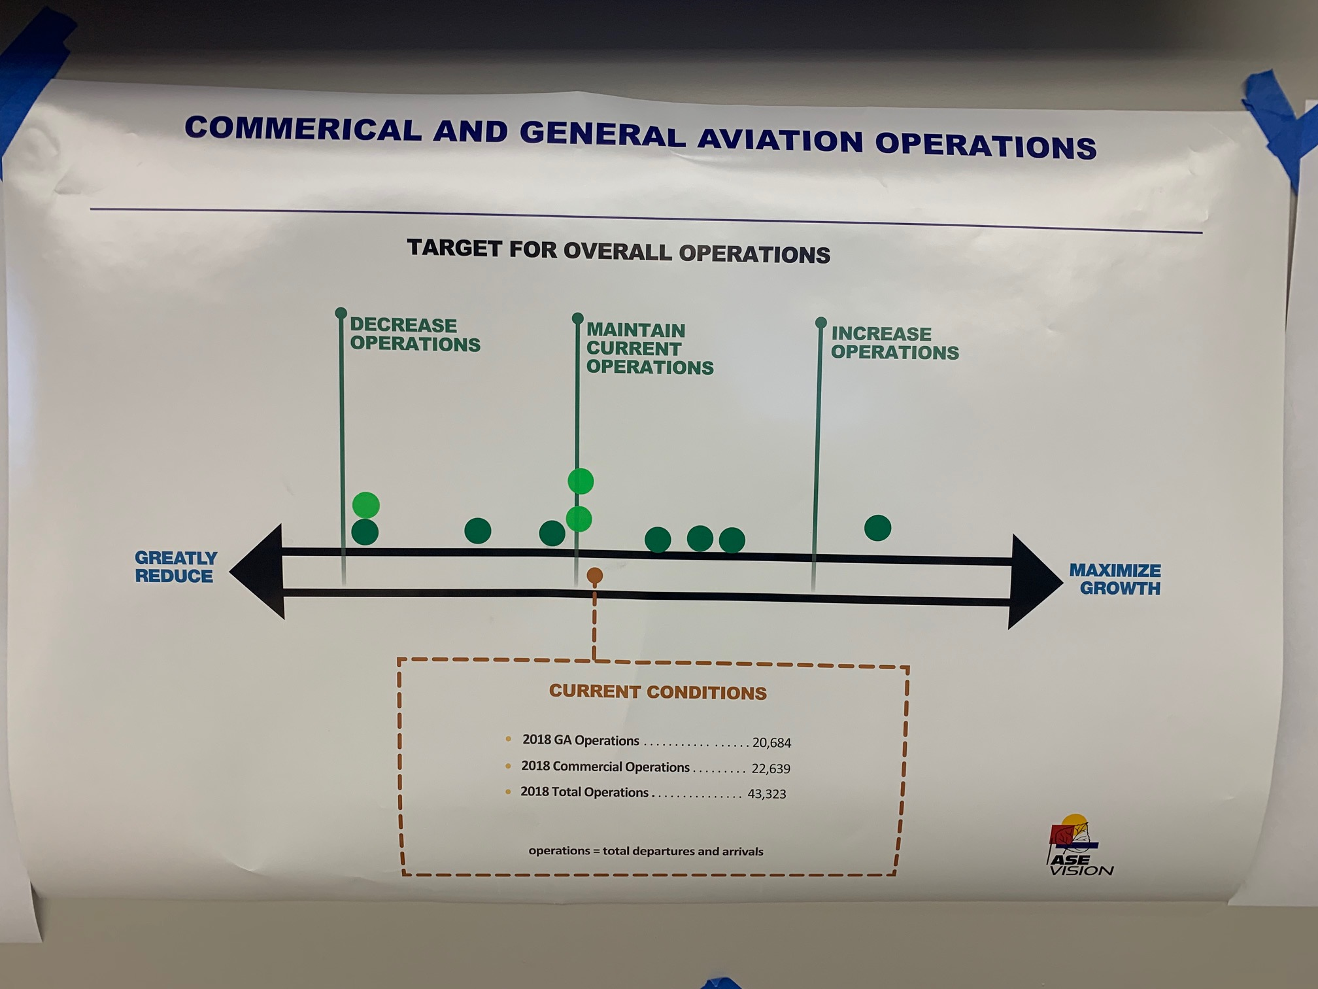

- Commercial Operations – Use this one
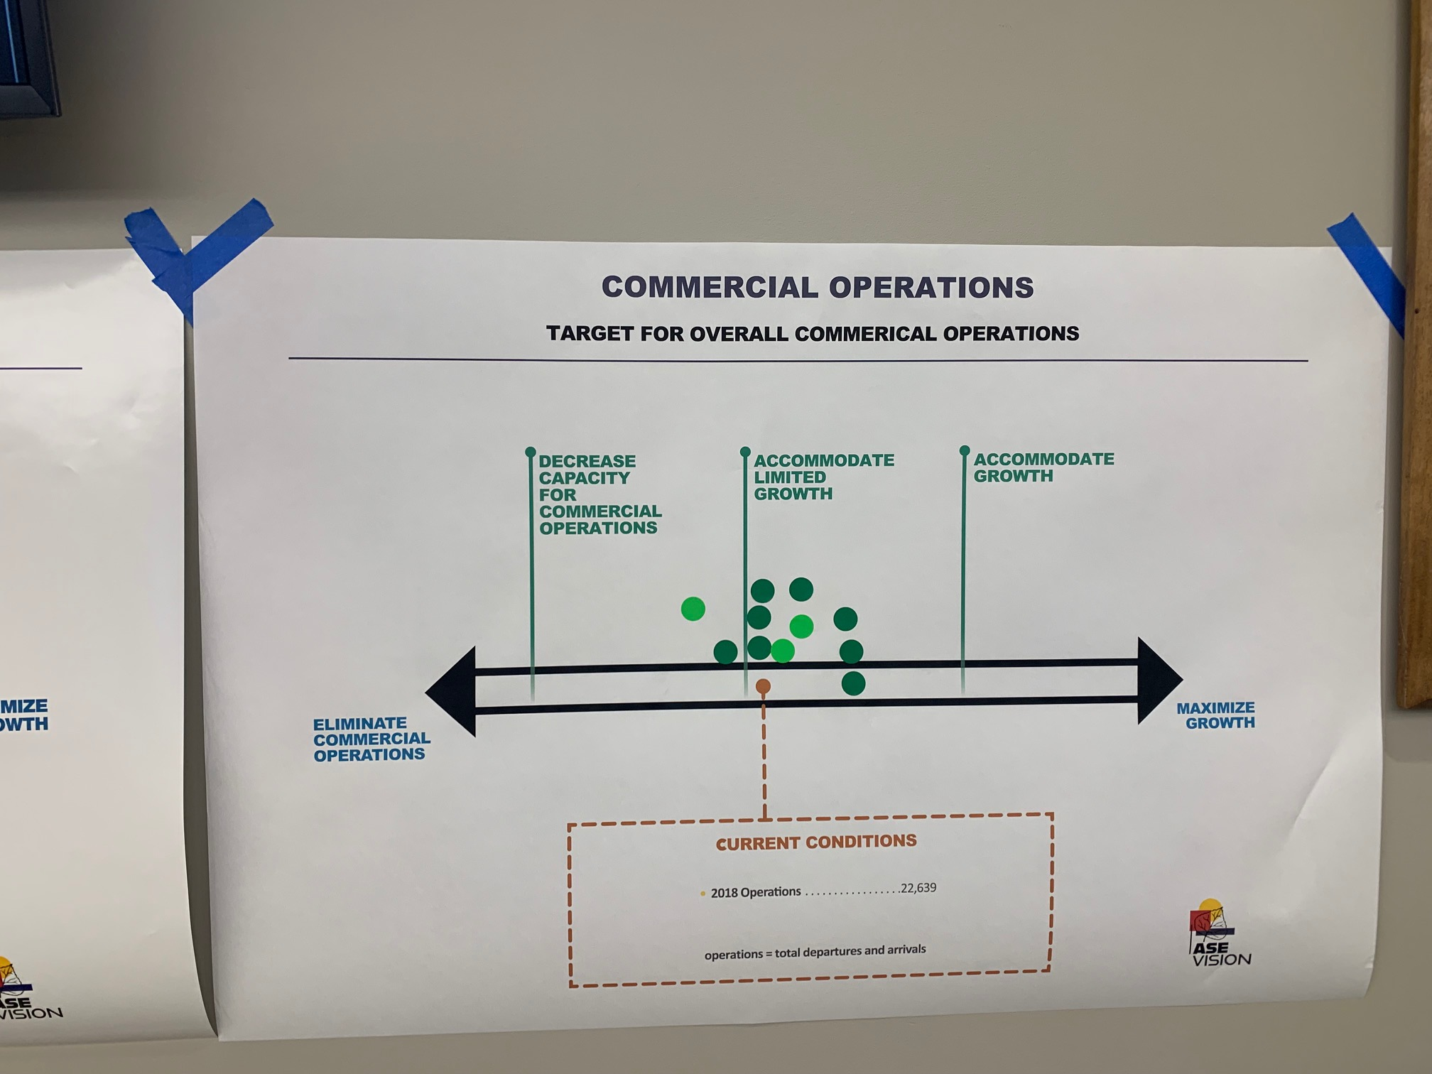
- GA Operations – Use this one
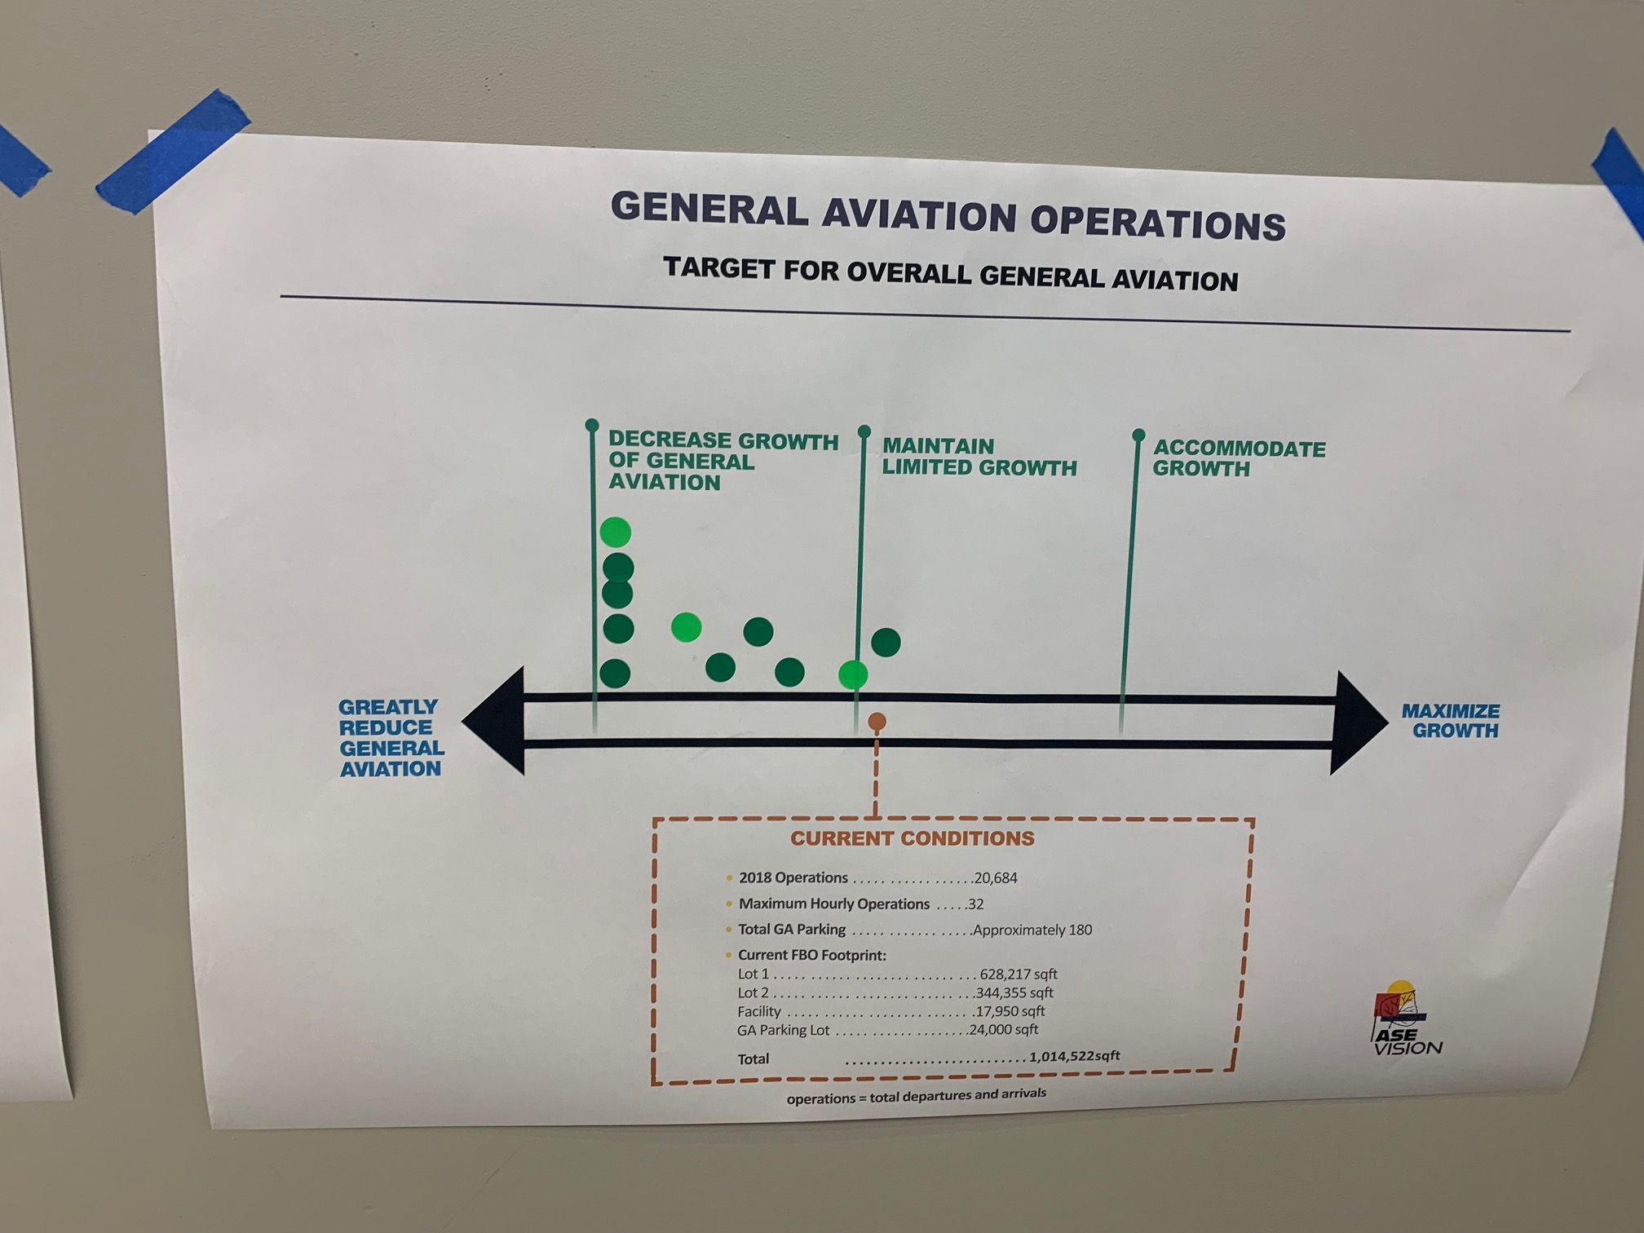
The GA and Commercial separated are much more important than the Total operations

- Total Local Pollution/Exhaust
Group agreed no specific definition of “local”
Should say at least 30% reduction – strive for more
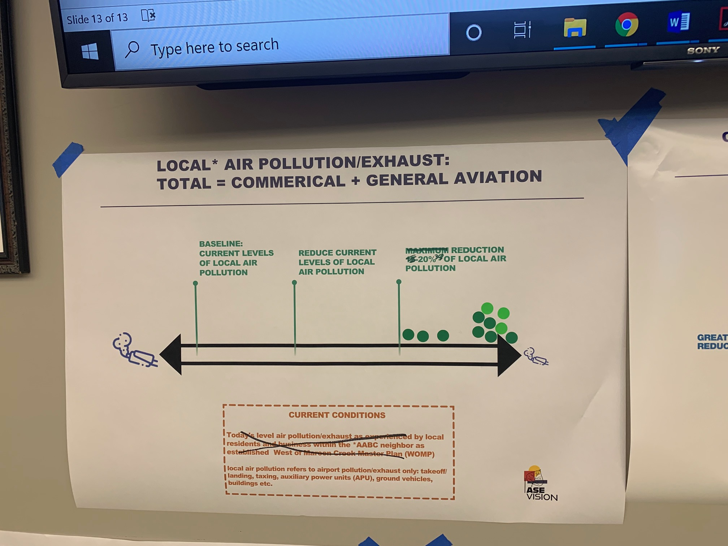
- Commercial Local Pollution/Exhaust
Should say at least 30% reduction – strive for more
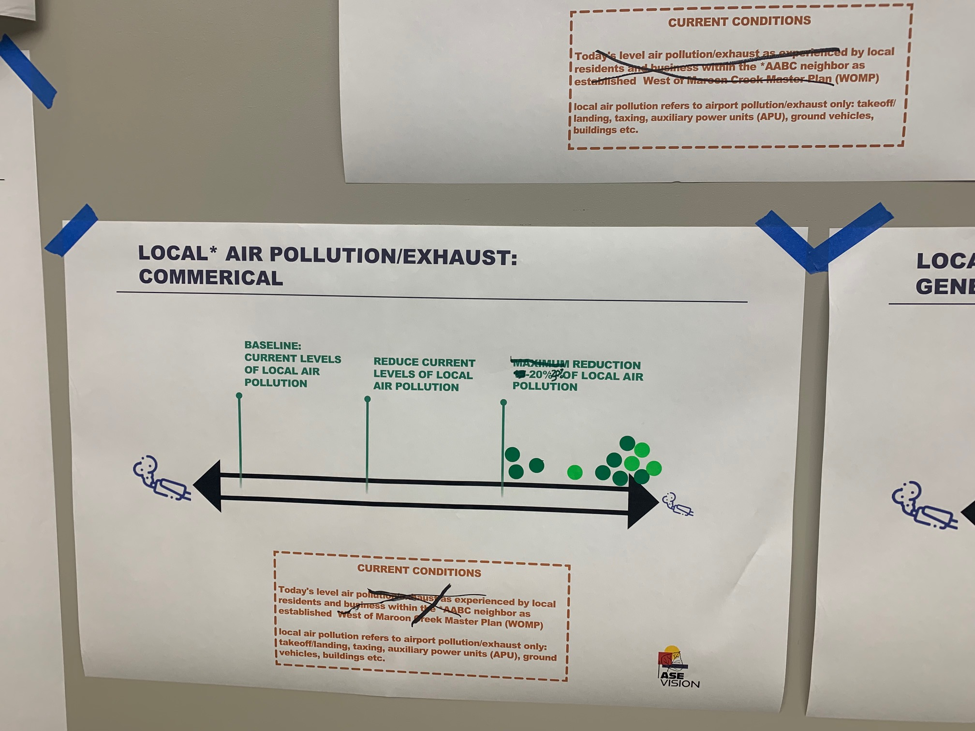
- GA Local Pollution/Exhaust
Should say at least 30% reduction – strive for more

