Basalt Chamber of Commerce

How to update your organization’s information in our database

The Basalt Chamber of Commerce utilizes a database called ChamberMaster to manage information about its members. There is a members-only portal called the Member Information Center which allows members to login to view and edit details. The database is used to feed information into www.basaltchamber.org, including the Directory, Hot Deals, Events, Job Postings and more. Members can add keywords to help customers who are searching for services, run reports to see hit statistics for your home page and other advertised items.

There are two major reasons why members should login and ensure that their organization’s information is accurate:

Internal use
The Chamber staff uses the database daily for member communication, outreach to company representatives, recordkeeping, referrals and billing. Accurate information allows us to help you do business better. If an individual is not listed in the database as a representative of a business/organization, they will not receive important updates from the Chamber.

External use – basaltchamber.org
There are different features members can use to promote their organization on the Chamber’s website. The links below are to the public-facing pages. Instructions for each feature are on the following pages.
- The Directory displays the organization in a central listing and provides each organization with its own webpage for visitors to learn more about the business/non-profit. All Basalt Chamber members receive an enhanced listing, which allows organization to add feature photos, videos, detailed descriptions and more.
  - For businesses who do not have a website, this directory page can serve as landing page for customer searching for your business.
  - For businesses with a website, it provides added SEO value and helps to improve the site’s Google ranking.
- Events – Events can be promoted on our website. The best method is to log into your account to create the event listing, then you can manage any future changes.
- Reports – Members can run reports to see traffic statistics for the organization’s home page and other advertised items.
- In addition to the Directory, there are Hot Deals, Job Postings, and additional benefits that can be listed.

If you have internet access, you will be able to edit your information by using the member login page. It is important to keep your organization’s information current. The following steps will help you to do this quickly and easily.
GET STARTED – LOG IN
Open a web browser:
- Visit to www.basaltchamber.org, click the Belong tab on the top. Within the drop-down options, click Member Login (middle column).
- Alternatively, visit http://business.basaltchamber.org/login/

Enter your username (typically an email address) and password. Click Continue.
- If you don’t know your username and password, click Forgot your username/password?. At the next screen, provide your email address. Your password will be sent to you if you have an account.
- NOTE: Only existing users in the Chamber’s database will have an account. Users not in the database will need to call 970-927-4031 to be added on the backend.

ChamberMaster has great documentation on how members can use the Member Information Center.

OVERVIEW - ROLES
Each member organization can have representatives with different levels of access within its profile in the database. Only the Primary representative and the Billing representative are able to add or delete other representatives. If one of these administrative roles needs to be changed and you cannot do so within the Member Information Center, please call the Chamber for assistance: (970) 927-4031.

Primary representative
The primary representative has admin privileges within the MIC to update the member business’s profile and serves as the main point of contact for all member communications. This role is typically held by the founder/owner. In larger organizations, the primary representative may be tied to HR or marketing roles.

Billing representative
The billing representative is the point of contact for all financial items, including billing and invoicing. The address associated with the billing representative is used for any financial related communications - please ensure that the correct mailing address is associated with this person. This role is typically held by the person responsible for financial matters – the CEO/founder/owner, head of Accounting/AP or the bookkeeper.

Representative
All other employees can be added to the member business’s profile, including individuals responsible for HR, marketing, volunteers…etc. Please add anyone who will interact with the chamber or would like to receive communications and updates from the chamber.
HOMEPAGE
Home
This button brings you back to the main page. From this page, you can register for upcoming Chamber events, see the % completion of your profile, and refer a business for membership.

Directory
This allows you to search Chamber member businesses, contacts, keywords and categories.

Events
View existing events, add/modify/manage your own events, view registrations for upcoming events, and view which events you have attended.

Resources Coming soon – not currently in use

Reports
View a summary of your organization’s visibility on www.basaltchamber.org.

News Not currently in use

Settings
The majority of an organization’s information is contained within this section. It is where you will go to make changes to your member profile.

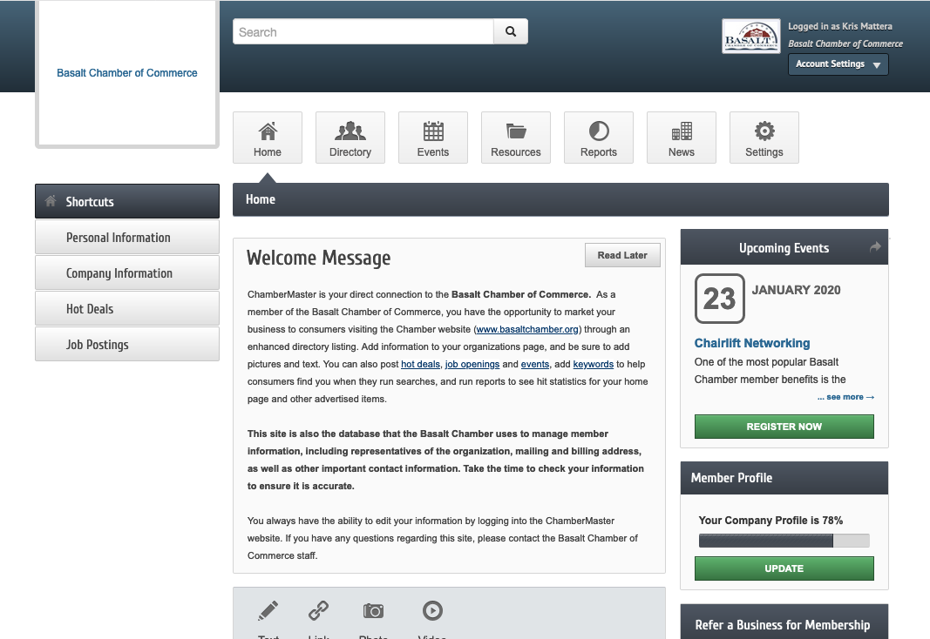
COMPANY DIRECTORY INFORMATION
How to add/edit/update your business information VIDEO | PDF
How to update your personal profile (account info) VIDEO | PDF

Click the Settings button (with the gear) in the upper right-hand part of the page.
In the left navigation, click the Company tab.
- Alternatively, access it via the top right Account Settings drop down > Company Information.

NOTE: Always click Save Changes at the bottom of the page when finished, otherwise it will not be saved.

Within the Company tab, there are different sections to manage details in the Directory:
- Profile Summary – Provides a high-level overview of the company’s profile
- Organization Information – Company name, contact information, establishment date, number of employees, and billing contact
- Employees – [Primary/Billing representatives only] Lists all representatives (employees) tied to the organization’s profile. This section is predominantly for internal use. It is the source of emails for members-only communications.
  - Click on an employee’s name to modify their information, including if they are ACTIVE, a Primary representative or a Billing representative.
  - NOTE: The address associated with the Billing contact serves as the mailing address for all invoices.
- Website Information – This is the information displayed on the organization’s page: company website, social media profiles, descriptions displayed in the directory page, hours, keywords
- Additional Information – not current in use
- Logos – Provides the header image, and logo on the organization’s page
- Photos – Provides an image gallery
- Video – YouTube videos can be uploaded to the organization’s page with an url
- Map Pin Information – Display where the organization is located, with Google Maps or with an image
- Membership Badge – coming soon

EVENTS
How to manage and use events VIDEO | PDF

HOT DEALS
How to submit a Hot Deal or Member to Member Deal VIDEO | PDF

JOB POSTINGS
How to submit a job posting | PDF

